BRACT’s
Vishwakarma Institute of Technology, Pune
Practical Implementation Sheet
Department: CSE-AI Semester: 5 Academic Year: 2026-27
Division: E Batch: 1 Practical No: 1
Roll no: 64 PRN No: 12412320 Name of Student: Samyak Shende
Subject Name : Deep Learning

Problem Statement : Install and configure TensorFlow/Keras in Google Colab. Perform data preprocessing, normalization, train-test split, and visualization on a sample dataset.

Algorithm :
- Start the program.
- Import the required libraries:
  - TensorFlow
  - Keras
  - Matplotlib
- Load the Fashion-MNIST dataset.
- Split the dataset into:
  - Training images and labels
  - Testing images and labels
- Normalize the pixel values by dividing each pixel by 255.0 so that the values lie between 0 and 1.
- Display a few sample images from the dataset for visualization.
- Create a Sequential Neural Network consisting of:
  - A Flatten layer to convert the 28×28 image into a 1D vector.
  - A Dense hidden layer with 128 neurons using the ReLU activation function.
  - A Dense output layer with 10 neurons using the Softmax activation function for multi-class classification.
- Compile the model using:
  - Optimizer: Adam
  - Loss Function: Sparse Categorical Crossentropy
  - Evaluation Metric: Accuracy
- Train the model using the training dataset for the specified number of epochs.
- Evaluate the trained model using the testing dataset.
- Predict the class labels for the test images.
- Compare the predicted labels with the actual labels.
- Save the trained model for future use.
- Stop the program.

Code :
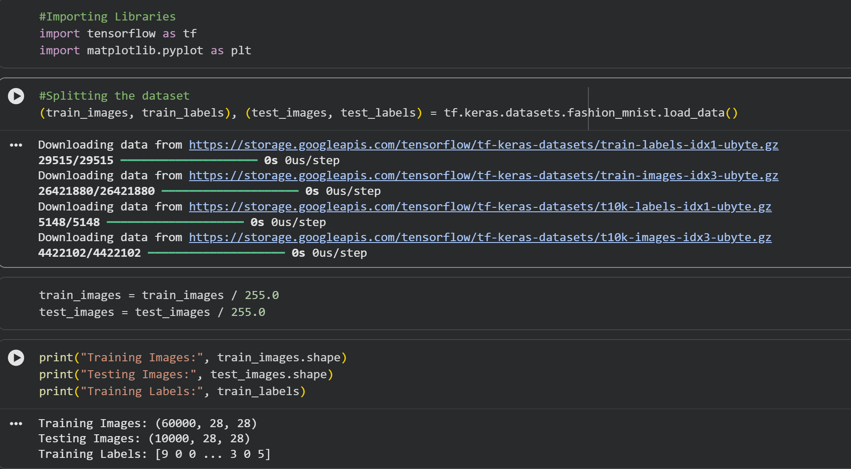
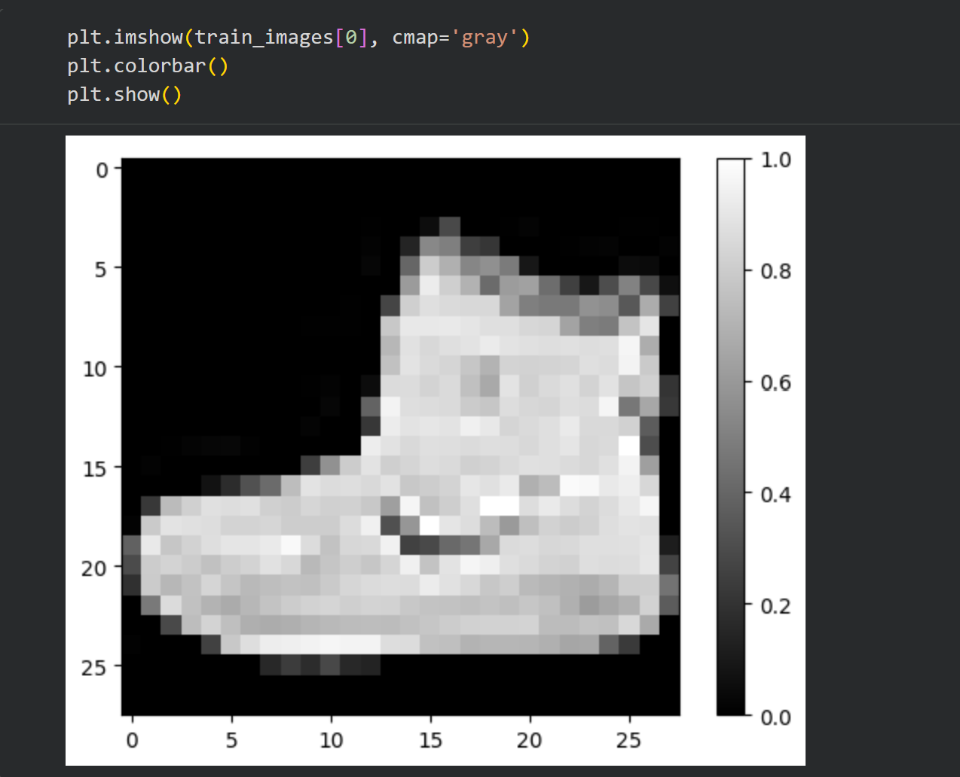
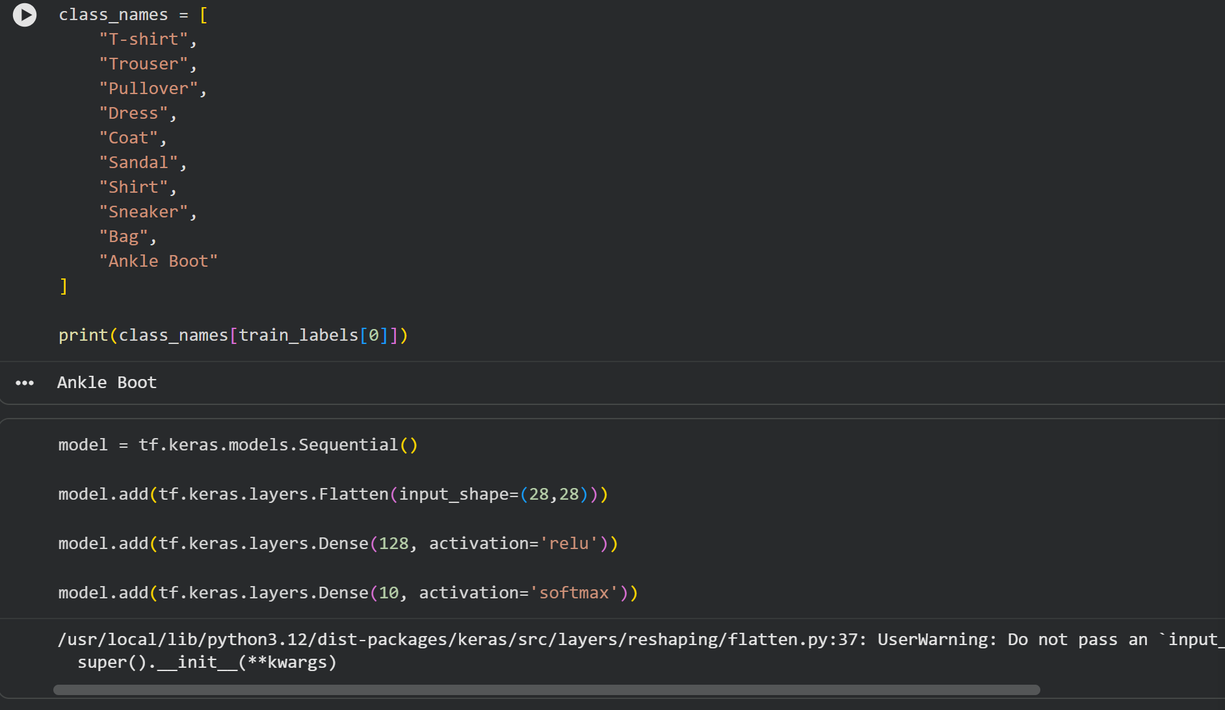
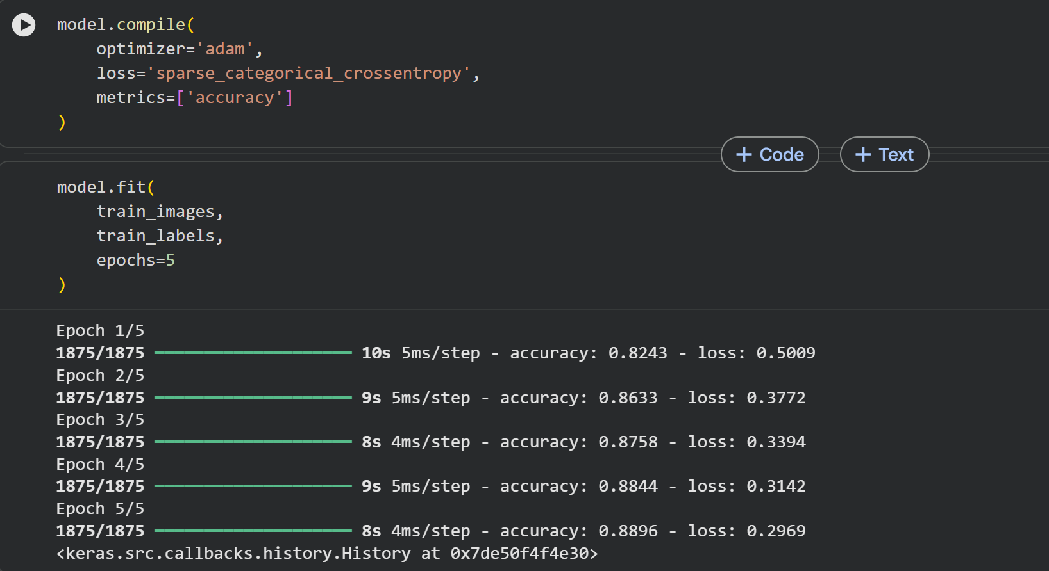
Output :
